

**Kedington Primary Academy**

**Anti-Bullying Policy**

|  |  |
| --- | --- |
| **Date of Policy** | **Summer 2022** |
| **Signed** | (Chair of Governors) |
| **Minuted** | (Date) |
| **Date of Next Review** | **Spring 2025** |

Our school is a place where every person has the right to be themselves, to be included and to learn in a safe and happy environment. Everyone at our school is equal and treats each another with respect and kindness.

**Aims and purpose of the policy**

Bullying of any kind is unacceptable and will not be tolerated at our school. At our school the safety, welfare and well-being of all pupils and staff is a key priority. We take all incidences of bullying seriously and it is our duty as a whole school community to take measures to prevent and tackle any bullying, harassment or discrimination.

We actively promote values of respect and equality and work to ensure that difference and diversity is celebrated across the whole school community. We want to enable our pupils to become responsible citizens and to prepare them for life in 21st Century Britain. These values reflect those that will be expected of our pupils by society, when they enter secondary school and beyond in the world of work or further study.

We are committed to improving our school’s approach to tackling bullying and regularly monitor, review and assess the impact of our preventative measures.

This policy should be viewed in conjunction with the school’s Behaviour Policy.

**1. Definition of bullying**

Bullying is hurtful or unkind behaviour which is deliberate and repeated. Bullying can be carried out by an individual or a group of people towards an individual or group. The **STOP** acronym can be applied to define bullying – **S**everal **T**imes **O**n **P**urpose.

The nature of bullying can be:

* **Physical –** such as hitting or physically intimidating someone, or using inappropriate or unwanted physical contact towards someone
* **Attacking property –** such as damaging, stealing or hiding someone’s possessions
* **Verbal –** such as name calling, spreading rumours about someone, using derogatory or offensive language or threatening someone
* **Psychological –** such as deliberately excluding or ignoring people
* **Cyber –** such as using text, email or other social media to write or say hurtful things about someone

Bullying can be based on any of the following things:

* **Race** (racist bullying)
* **Religion or belief**
* **Culture or class**
* **Gender** (sexist bullying)
* **Sexual orientation** (homophobic or biphobic bullying)
* **Gender identity** (transphobic bullying)
* **Special Educational Needs (SEN) or disability**
* **Appearance or health conditions**
* **Related to home or other personal situation**
* **Related to another vulnerable group of people**

**No form of bullying will be tolerated and all incidents will be taken seriously.**

**2. Reporting bullying**

**PUPILS WHO ARE BEING BULLIED:** If a pupil is being bullied they are encouraged to not retaliate but to tell someone they trust about it such as a friend, family member or trusted adult. They are also encouraged to report any bullying incidents in school:

* Report to a teacher – their class teacher or any other teacher including the headteacher or deputy headteacher
* Tell an older child or friend who in turn can help them tell a teacher or other member of staff
* Tell any other adult staff in school – such as lunchtime supervisors, learning support assistants or the school office
* Tell an adult at home
* Report anonymously through class Worry Box or ‘I wish my teacher knew…’ activities
* Call ChildLine to speak with someone in confidence on 0800 1111

Reporting – roles and responsibilities

**STAFF:** All school staff, both teaching and non-teaching (for example midday supervisors, caretakers, office staff) have a duty to report bullying, to be vigilant to the signs of bullying and to play an active role in the school’s measures to prevent bullying. If staff are aware of bullying, they should reassure the pupils involved and inform their class teacher.

**SENIOR STAFF:** The Senior Leadership Team and the head teacher have overall responsibility for ensuring that the anti-bullying policy is followed by all members of staff and that the school upholds its duty to promote the safety and well-being of all young people.

**PARENTS AND CARERS:** Parents and carers should look out for potential signs of bullying such as distress, lack of concentration, feigning illness or other unusual behaviour. Parents and carers should encourage their child not to retaliate and support and encourage them to report the bullying. Parents and carers can report an incident of bullying to the school either in person, or by phoning or emailing the school office or a member of staff.

**PUPILS:** Pupils should not take part in any kind of bullying and should watch out for signs of bullying among their peers. They should never be bystanders to incidents of bullying, but should offer support to the victim and, if possible, help them to tell a trusted adult.

**3. Responding to bullying**

**When bullying has been reported, the following actions will be taken:**

* Staff will record the bullying on an incident reporting form and give a copy to the headteacher. The incident and any follow up actions will be recorded on CPOMs.
* The headteacher will monitor incident reporting forms analysing and evaluating the results
* The headteacher will produce termly reports summarising the information, which will be reported to the governing body
* Staff will offer support to the target of the bullying in discussion with the pupil’s class teacher. Individual meetings will then be held with any target of bullying to devise a plan of action that ensures they are made to feel safe and reassured that the bullying is not their fault
* Staff will pro-actively respond to the bully who may require support. They will discuss with the target’s class teacher to devise a plan of action
* Staff will decide whether to inform parents or carers and where necessary involve them in any plans of action
* Staff will assess whether any other authorities (such as police or the local authority) need to be involved, particularly when actions take place outside of school

**4. Bullying outside of school**

Bullying is unacceptable and will not be tolerated, whether it takes place inside or outside of school. Bullying can take place on the way to and from school, before or after school hours, at the weekends or during the holidays, or in the wider community. The nature of cyber bullying in particular means that it can impact on pupils’ well-being beyond the school day. Staff, parents and carers, and pupils must be vigilant to bullying outside of school and report and respond according to their responsibilities as outlined in this policy.

**5. Derogatory language**

Derogatory or offensive language is not acceptable and will not be tolerated. This type of language can take any of the forms of bullying listed in our definition of bullying. Any use of such language, including casual use, will be challenged by staff and recorded and monitored on a prejudice related incident sheet and follow up actions and sanctions, if appropriate, will be taken for pupils and staff found using any such language.

**6. Prejudice-based incidents**

A prejudice-based incident is a one-off incident of unkind or hurtful behaviour that is motivated by a prejudice or negative attitudes, beliefs or views towards a protected characteristic or minority group. It can be targeted towards an individual or group of people and have a significant impact on those targeted. All prejudice-based incidents are taken seriously and recorded and monitored in school, with the head teacher regularly reporting incidents to the governing body. This not only ensures that all incidents are dealt with accordingly, but also helps to prevent bullying as it enables targeted anti-bullying interventions.

**7. School initiatives to prevent and tackle bullying**

**We use a range of measures to prevent and tackle bullying including:**

* A child-friendly anti-bullying policy *(Appendix 1)* ensures all pupils understand and uphold the anti-bullying policy
* The PSHE programme of study includes opportunities for pupils to understand about different types of bullying and what they can do to respond and prevent bullying
* School assemblies help raise pupils’ awareness of bullying and derogatory language
* Difference and diversity are celebrated across the school through diverse displays, our carefully thought out literacy spine, other books and images. The whole school participates in events such as Anti-Bullying Week
* The school values of equality and respect are embedded across the curriculum to ensure that it is as inclusive as possible
* Stereotypes are challenged by staff and pupils across the school
* Restorative justice provides support to targets of bullying and those who show bullying behaviour
* Pupils are continually involved in developing school-wide anti-bullying initiatives through consultation with groups such as the School Council and through the anti-bullying survey
* Working with parents and carers and in partnership with community organisations to tackle bullying, where appropriate

**8. Training**

The head teacher is responsible for ensuring that all school staff, both teaching and nonteaching (including midday supervisors, caretakers and office staff) receive regular training on all aspects of the anti-bullying policy.

**9. Monitoring and reviewing**

The head teacher is responsible for reporting to the governing body on how the policy is being enforced and upheld, via the termly report. The governors are in turn responsible for monitoring the effectiveness of the policy via the termly report and by in-school monitoring such as learning walks and focus groups with pupils. The policy is reviewed every 3 years.

Appendix 1 – Child-Friendly Anti-Bullying Policy

**Our Anti-Bullying Policy**

This school is a place where everyone has the right to be themselves. It’s a place where everyone can feel safe, be happy and learn.

Everyone at our school is equal and acts with respect and kindness towards each other. Our school is a bully-free place.

What is bullying?

Bullying is when a person is hurtful or unkind to someone else, on purpose and more than once. Bullying can be done by one person or by a group of people and can be towards one person or a group of people. A useful way to remember bullying is



Bullying can be:

* Hitting or saying you are going to hit someone
* Touching someone when they don’t want you to
* Calling someone names, teasing, using rude language or saying nasty things about someone to them or to other people
* Stealing or damaging someone else’s belongings
* Sending hurtful or unkind texts or emails or online messages to someone or about someone

Bullying can be about

* **Race** or **ethnicity** (racist bullying)
* Religion or belief
* Family and **culture**
* **Sexist** bullying
* **Homophobic**, **biphobic** or **transphobic** bullying
* What someone looks like
* Where someone lives

Why does bullying happen?

Although bullying doesn’t happen very much in this school, it might happen. Bullies can be older or younger than you, bigger or smaller than you. Bullies pick on people who may be different in some way and try to make them feel worse about themselves. If you are being bullied remember that it is never your fault.

When does bullying happen?

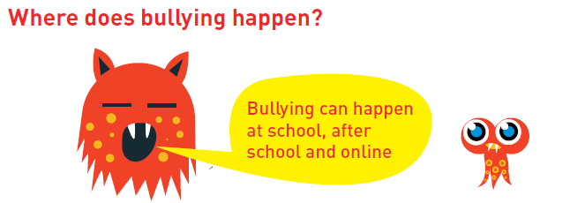

What should I do if I think someone is being bullied?

Talk to the person and ask if they are okay and try to find out if they are being bullied. If they are, ask if you can help them talk to a teacher or someone they trust.

What should I do if I’m being bullied?

* If you are being bullied it is important to tell someone you trust. Tell an adult or friends, either at school or at home. If you have already told an adult about bullying, you can still tell them again. You can:
* Tell a teacher – your class teacher or any other teacher, including Mrs Ahlquist or Mrs Doherty
* Tell any other adult staff in school, such as midday supervisor, office staff, learning support assistant
* Tell an adult at home
* You can also write a note about bullying and put it in your class’s Worry Box
* You can also call ChildLine at any time for free on 0800 1111. They will not tell anyone what you have said.

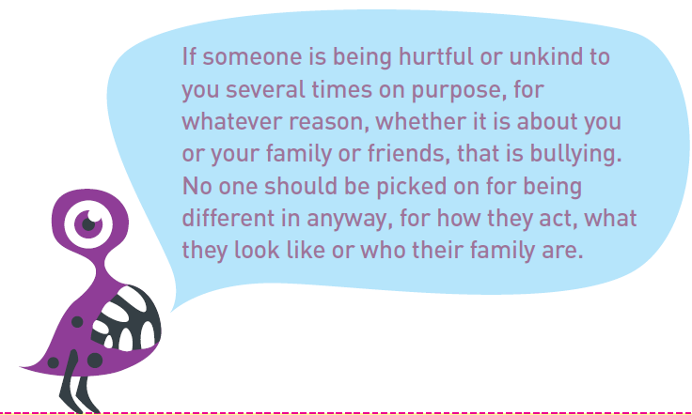If you tell a teacher or an adult at school they will be able to help you. They may tell another teacher like your class teacher, or a parent or carer so that they can help you. Telling an adult will never make the bullying worse. They will talk to you and the bully to find ways to stop the bullying.

Glossary

|  |  |
| --- | --- |
| biphobic bullying | Saying unkind or nasty things because someone is **bisexual**, or because you think they are. |
| bisexual | Someone who falls in love with, or wants to have a relationship with someone of the same gender as them, or with someone of a different gender to them. |
| culture | A way or life or beliefs. |
| ethnicity | Connected to or related to different racial or cultural group of people |
| gay | Someone who falls in love with, or wants to have a relationship with people who are the same gender as them. |
| homophobic bullying | Saying unkind or nasty things because someone is **lesbian**, gay, or because you think they are, or they have two mums or two dads. |
| lesbian | A woman who falls in love with, or wants to have a relationship with other women. |
| race | One of the major groups which human beings can be divided into according to their physical features, such as the colour of their skin. |
| sexist bullying | Bullying someone because of their gender. For example, because they are a boy or a girl or saying they are acting ‘like a boy’ or ‘like a girl’ |
| transphobic bullying | Saying unkind things because someone is trans or because you think they are **trans**, or being nasty about people who are **trans**. |
| trans | People who feel the gender they were given as a baby doesn’t match the gender they feel themselves to be. For example, someone who was given the gender ‘boy’ as a baby but feels like a girl. |

Appendix 2 – Bullying & Prejudice Related Incident Reporting Form

|  |  |  |  |  |  |  |  |  |
| --- | --- | --- | --- | --- | --- | --- | --- | --- |
| Section A: Staff details | | | | | | | | |
| Date of completing form: | | | | | | | | |
| Name of staff: | | | | | | | | |
| *After completion this form needs to be handed to the Headteacher* | | | | | | | | |
| Section B: Details of incident | | | | | | | |
| Bullying (tick) | | | | Prejudice- based incident (tick) | | | | |
| Nature of incident (tick all that apply: | | | | | | | | |
| Physical | Property | | Verbal | | Psychological | | Cyber | |
| Form of bullying or incident (tick all that apply): | | | | | | | | |
| Race | | Culture | | | | Religion or belief | | |
| Sexual orientation (homophobic or biphobic) | | Gender identity – transphobic | | | | Gender – sexism | | |
| Special Educational Needs or Disability (SEND) | | Appearance or health condition | | | | Related to home or other circumstances | | |
| Details fo those involved: Record all those involved, whether adults, pupils, visitor from the school community or outside | | | | | | | | |
| **Target of bullying/incident:** | Name: | | Year group: | | Class teacher: | | Other relevant information: | |
| **Person responsible for bullying/incident** | Name: | | Year group: | | Class teacher: | | Other relevant information: | |
| Details of incident: | | | | | | | | |
| Date | | Place | | | | Time | | |
| Witnesses | | | | | | | | |
| Repeat incident or serious incident? | | | | | | | | |
| What happened? | | | | | | | | |
| Action taken: | | | | | | | | |
| Details of others informed or notified: | | | | | | | | |
| Actions for follow up: | | | | | | | | |
| Date for review: | | | | | | | | |